**İSKELETİMİZ KAÇ ÇEŞİT KEMİKTEN OLUŞMUŞTUR?**

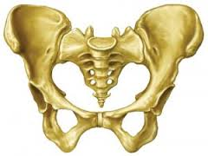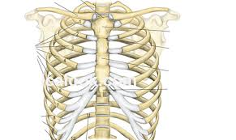

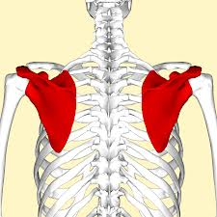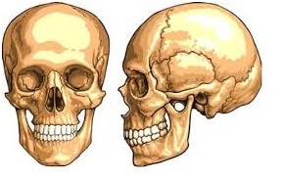

……………………………………………………………………………………………………………………………………………………………………………………….………………………………………………………………………………………………………………………………………………………………………………………..

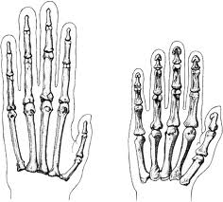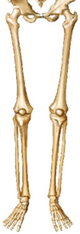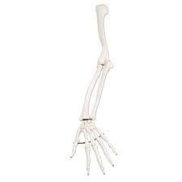

**C:\Users\3A\Desktop\imagesCAEDNXCV.jpg**

………………………………………………………………………………………………………………………………………………………………………………………………………………………………………………………………………………………………………………………………………………………………………………

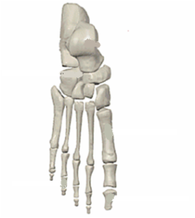**C:\Users\3A\Desktop\Adsızomur.png**

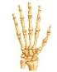

………………………………………………………………………………………………………………………………………………………………………………………………………………………………………………………………………………………………………………………………………………………………………………

**M.Nazan GÖKŞEN**